https://tools.cisco.com/RPFA/profile/edit_contact.do

log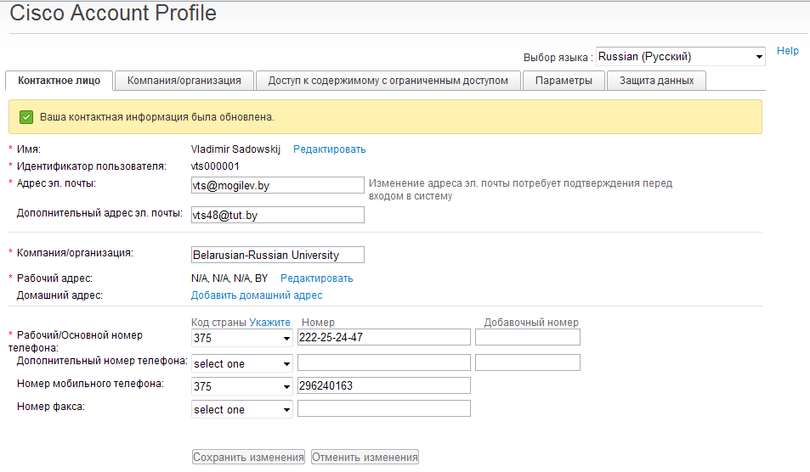: vts000001

pasw:DbrfNhf55